Week 3 Readings
As early in the week as possible, please read:
- Week 3 online lectures.
- The following sections from the Chapter 4 (Quadrilaterals) and Chapter 5 (Similar Triangles) of the text Elementary Geometry:
  - Section 4.1 pg. 178 (Also read examples 1-6),
  - Section 4.2 pg. 187 (Also read examples 1-5),
  - Section 4.3 pg. 195 (Also read examples 1-6),
  - Section 4.4 pg. 203 (Also read examples 1-6),
  - Section 5.1 pg. 218 (Also read examples 1-7),
  - Section 5.2 pg. 225 (Also read examples 1-7),
  - Section 5.3 pg. 233 (Also read examples 1-6),
  - Section 5.4 pg. 242 (Also read examples 1-6).
Week 3 Assignments Overview
Assignment Summary Week 3: | Due Date
Assignment 1: Discussion Questions | Friday, March 6, 2009
Assignment 2: Exam | Sunday, March 8, 2009
Assignment 3: Discussion on Exam | Tuesday, March 10, 2009
Using the navigation on the left, please proceed to the next page.

Week 3
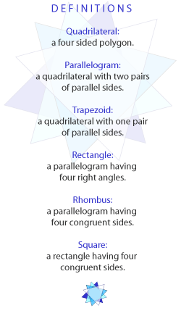
Learning Outcomes
- Identify the different quadrilaterals: parallelogram, kite, rectangle, square, rhombus, and trapezoid.
- Identify properties of the different quadrilaterals.
- Use the Pythagorean theorem.
- Define similarities of triangles and polygons.
- Use the concept of ratio, rates, and proportions with similar polygons.

Quadrilaterals
This week, we will cover different types of quadrilaterals, trapezoids, ratio and proportion in geometric context, triangles, and polygons. We will also cover Pythagorean theorem in particular.
A quadrilateral is a polygon that has four sides. There are two major types of quadrilaterals: trapezoids and parallelograms. The trapezoid has exactly one pair of parallel sides while the parallelogram has two pairs of parallel sides. You need to be aware of some of the basic properties of a parallelogram and how you can prove that a quadrilateral is a parallelogram.
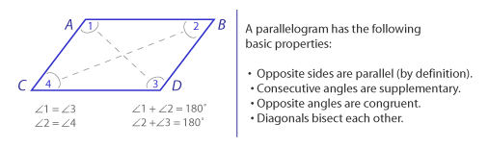
By definition, a kite is a quadrilateral with two distinct pairs of congruent adjacent sides.
How can we prove that a quadrilateral is a parallelogram? There are a few ways to do it. To prove that a quadrilateral is a parallelogram, show that any one of the following is true:
- Opposite sides are parallel.
- Opposite sides are congruent.
- Opposite angles are congruent.
- Diagonals bisect each other.
- A pair of sides is both parallel and congruent.

Trapezoid
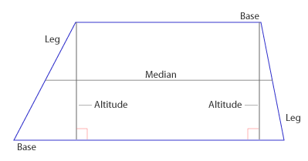
Unlike a parallelogram, a trapezoid has exactly one pair of parallel sides. The parallel sides are called the bases of the trapezoid, while the nonparallel sides are referred to as the legs of the trapezoid. Two additional terms that are used in connection with trapezoids are altitude and median. An altitude of a trapezoid is a segment drawn from any point on one of the parallel sides (base) perpendicular to the opposite side (of other base). The median of a trapezoid is the segment that joins the midpoints of the nonparallel sides (legs). According to the median of a trapezoid theorem, the median of a trapezoid is parallel to the bases and has a length equal to one-half the sum of the length of the bases. Let's say for example, you were given the following problem:
The length of the lower base of a trapezoid is 3 times the length of the upper base. If the median has a 24-inch length, find the lengths of the bases. The solution then would be as follows:
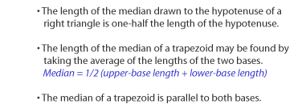
Let a = the length of the upper base
Then, 3a = the length of the lower base
Since the sum of lengths of bases is twice the median, we have a + 3a = 2 x 24.
Solve for a, we get a = 12, and 3a = 36.
If the legs of a trapezoid are congruent, then the trapezoid is called an isosceles trapezoid. An isosceles trapezoid features some special properties that are not found in all trapezoids, and you can use these properties to prove that the trapezoid being discussed is an isosceles trapezoid. The properties of an isosceles trapezoid are:
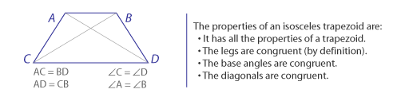

Ratios, Rates, and Proportions
You need to know the similarity of polygons, with an emphasis on triangles. Before we can go further into that, you need to understand the concept of ratios, rates, and proportions, and the ways in which proportions arise in geometric situations.
The ratio of two numbers a and b, where b is not equal to 0, is the quotient a/b. The numbers a and b are referred to as the terms of the ratio. You can have the ratio written as a/b, a to b, or a:b. When writing the ratio, it is preferable to write it in its simplest form, i.e., in reduced fraction form.
For example, 75/100 would be written as 3/4 or 3:4 (read as "3 to 4"). You can have different units of measurement for the two numbers. For example, if you have a person who travels 150 miles in 3 hours then the ratio of the distance traveled to the time traveled is 150miles/3 hours. And we can reduce this to 50 miles/hour, which happens to be the average rate of speed during the trip.
So, a rate is a quotient that compares two quantities that are incommensurable (no common unit of measurement). If, however, a ratio is formed in order to determine how many times larger or smaller one value is than another, both quantities must have the same unit of measurement.
For example, if the measure of angle A is 60 and angle B is a right angle, find the ratio of the measure of angle A to the measure of angle B.
We know that the ratio will be the measure of angle A to the measure of angle B. In this case, both angle measures have the same unit of measurement. So, we can proceed to write 60/90 = 2/3 or simply 2:3. In this particular lecture, you will be dealing mostly with application problems that involve measures of angles.
A proportion is an equation that states that two ratios are equal. For example, a/b = c/d.
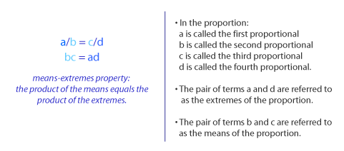
Recall how we solve proportions using cross-products or cross-multiplying. It is referred as the "means-extremes property": the product of the means equals the product of the extremes.

Similar Triangles and Polygons
What do we mean when we say that two geometric shapes are similar? Usually, two figures are similar if they have the same shape. In addition, if the two figures have the same shape and all corresponding parts have equal measures, the two figures are congruent.
Two polygons are similar if their vertices can be paired so that corresponding angles are congruent and the ratios of the lengths of all corresponding sides are equal. This means that each vertex of the first polygon is matched with exactly one vertex of the second polygon. Take note that congruent polygons have the same size and shape, while similar polygons have only the same shape.
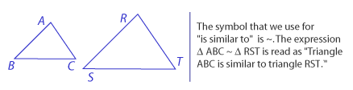
If we are told that two polygons are similar, it may be concluded that each pair of corresponding angles are congruent and the ratios of the lengths of all pairs of corresponding sides are equal.
Sometimes, you will be required to provide proof that triangles are similar. To show that two triangles are similar, we need to demonstrate that three pairs of corresponding angles are congruent and that the ratios of the lengths of three pairs of corresponding sides are the same. This can be quite a bit of work. We can use a shortcut method based on the following corollary:
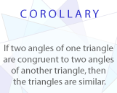
So, in essence, we just need to show that two angles of one triangle are congruent to two angles of another triangle to show proof that the two triangles are similar.
It is also important to know that the lengths of corresponding sides of similar triangles are in proportion. In addition, the lengths of corresponding altitudes of similar triangles have the same ratio as the lengths of any pair of corresponding sides.

Pythagorean Theorem
In a right triangle, the side opposite to the angle is called the hypotenuse, and each of the remaining sides is called a leg. We cannot discuss right triangles without talking about the Pythagorean Theorem.
The theorem is useful for it provides us with a means for finding the length of any side of a right triangle, given the lengths of the other two sides. The sides are related by the equation: (Hypotenuse)² = (leg 1)² + (leg 2)². In other words, the square of the length of the hypotenuse of a right triangle is equal to the sum of the squares of the lengths of the legs. If c is the hypotenuse, and a and b are the legs, then we have c² = a² + b². If you know the values of a and b, then you can find c by taking the square root of a² + b².
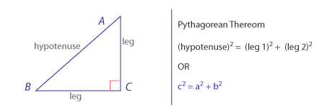
Most of the time, you will get whole numbers for a, b, and c values. Any set of three whole numbers x, y, and z is called a Pythagorean triple if the numbers satisfy the equation z² = x² + y². If {x, y, z} is a Pythagorean triple, then so is the set that includes any whole number multiple of each member of this set.
For example, if the set {3, 4, 5} is a Pythagorean triple, so is the set {6, 8, 10}. Sometimes, it helps to memorize the sets of Pythagorean triples to save some time and effort when solving problems involving right triangles.

Special Right Triangle Relationships
There are two special right triangles that you need to become familiar with: the 30-60 right triangle (or 30-60-90) and the 45-45 right triangle (or 45-45-90). For each one, there are some side relationships that need to be noted.
The 30-60 right triangle side relationships include:
- The length of the shorter leg (the side opposite the 30 degree angle) is one-half the length of the hypotenuse.
- The length of the longer leg (the side opposite the 60 degree angle) is one-half the length of the hypotenuse multiplied by 3.
- The length of the longer leg is equal to the length of the shorter leg multiplied by 3.
The 45-45 right triangle is the isosceles triangle. Since the legs of an isosceles right triangle are congruent, the angles opposite must also be congruent. That is why we have the measure of each acute angle in an isosceles right triangle to be 45 degrees. The 45-45 right triangle side relationships include:
- The lengths of the legs are equal.
- The length of the hypotenuse is equal to the length of either leg multiplied by 2.
- The length of either leg is equal to one-half the length of the hypotenuse multiplied by 2.

Assignment 1: Discussion Questions
By Friday, March 6, 2009 choose two of the discussion questions, and post your responses in the Discussion Area. Your response should reflect an understanding of the material covered as it applies to your life, work, and educational experiences. Start reviewing and responding to your classmates as early in the week as possible; post comments on at least two of your classmates' submissions to the Discussion Area. Please refer to the policy for participation found in the Educational Commitment Statement.
Grading Criteria | Maximum Points
Correct explanation of concepts. | 4
Well-formed conclusions. | 4
Participation in discussion with class, feedback, and comments. | 4
Correct spelling and grammar. | 4
Total: | 16
For assistance with any problems you may have when completing this assignment—OR—to offer your assistance to classmates, please use the Problems and Solutions Discussion area located through the left side navigation link.
DQ2 - In your opinion, are congruent polygons similar? Why? Is the reverse also true, i.e., are similar polygons also congruent? If yes, in what situation will this hold true? If no, explain.
DQ 3 - Explain why the following definition of parallel segments is faulty:
"Two segments are parallel if they do not intersect." Give a good definition for parallel segments.
DQ 4- What are the differences between straight, right, acute, and obtuse angles?
DQ 5 - We can use the Pythagorean theorem to solve problems that involve right triangles. Provide an example of a day-to-day situation that involves right triangles and the use of the theorem.
Assignment 3: Discussion on Quiz
Your facilitator will assign four questions from the Week 3 quiz; by Tuesday, March 10, 2009, present to the class how you solved these questions. Post your responses to this Discussion Area.
Review and critique the work of at least two other students by the end of the week and post your comments to the Discussion Area.
Grading Criteria | Maximum Points
The solutions present show understanding of concept. | 4
Participation and feedback. | 4
Total: | 8
For assistance with any problems you may have when completing this assignment—OR—to offer your assistance to classmates, please use the Problems and Solutions Discussion area located through the left side navigation link.
6. Which statement is true?
Every rectangle is a square.
The diagonals of a parallelogram must be congruent.
The diagonals of a rhombus must be congruent.
The diagonals of a rhombus must be perpendicular.
7. A triangle has sides of lengths 3, 4, and x. Determine all possible values of x so that the triangle is a right triangle.
x = 5
x = 1 or x = 5
x =�sqrt 7
x = 5 or x = sqrt 7
12. It is given that RST~ XYZ. If RS = 8, ST = 11, RT = 12, and XY = 4, find XZ.
XZ = 5
XZ = 6
XZ = 8
15. In a 45 - 45 - 90 triangle, the length of the hypotenuse is 10 times square root of 2. Find the exact length of each leg.
12
10
15
None of these

